**Activity Space**

**(Q&A: Thinking on your feet)**

**Activity 1a**

* You will be sharing an insightful/ interesting industry trend with a peer.
* Consider the Context, Audience and Purpose. Then, consider what to say and how to say it.
* 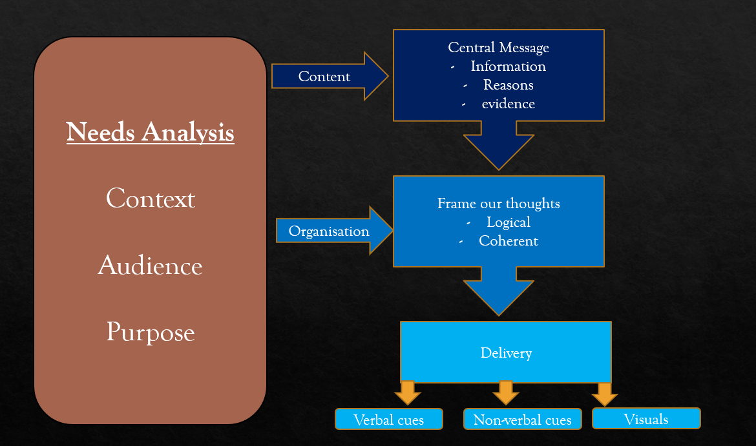

**Activity 1b**

* Speaker: Share an insightful/interesting industry trend that you have found.
* Receiver: Please give some feedback by commenting on what has been shared or by asking a question.
* Swop over (7 mins each

***Think about it***

* *How did your peers give feedback?*
* *What type of questions did your peers ask?*

**Activity 2 (Swop Partners)**

* Speaker: Share an insightful/interesting industry trend that you have found.
* Receiver: Please give some feedback by commenting on what has been shared or by asking a question.

**Let’s discuss**

* In what situations does one take part in a Q&A?
* What do you think is important during a Question & Answer session?

**Activity 3**

* **How would you respond to the following comments?**

|  |  |
| --- | --- |
| Comment 1:  *“There are dozens of little start-ups doing exactly what you’re doing! Then there are all those big guys, with their entrenched market share. It’s a jungle out there, and you’re only just getting off the ground! What on earth makes you think you can survive?”* | Comment 3:  *“You look like a kid! I doubt that you’ve been in the business very long. I’ve been in the industry since before you were born, and now you come in here and tell me how I should run my business. Where do you get off telling me what to do?”* |
| Comment 2:  *“Wait a minute! You tell me that your product is going to save us money, and then you quote a price that’s twice as much as your competitor asks! That’s outrageous! Where do you get off charging so much?”* | Comment 4:  *“Your new solution appears to be very effective, but you’ve only just released it. You don’t know if it has any kinks (flaws). I’d like to see it field-tested before I commit. It’s not for us at this time.”* |

**Please discuss:**

* What’s the **central issue**?
* How would you **respond** to the following comment?
* Let’s do comment 1 first (2 mins)

|  |  |
| --- | --- |
| Room 1 (Musfirah, Tai) | Room 2 (Haofeng, Anvitha) |
| Comment 1  -The market is very competitive. The central issue is that the comment is very discouraging to the listener and not constructive, he should instead give feedbacks that prompt the listener to think about his/her differentiating factor.  -Be confident, back it up with facts and testimonials.  Comment 2  -Customer felt betrayed about the high cost of product. He/she doesn’t understand why he/she had to be charged higher, and looking at it in the current situation, not in the long run.  -Explain the relatively higher cost now and the amount of money to be saved in the long run  Comment 3  -The client is worried about the inexperience of the person based on age, and couldn’t accept criticism from the speaker.  -Respectfully show the client his/her portfolios and all the previous projects he/she has worked with to assure the client. He/She must also give feedbacks respectfully in view of the client’s seniority.  Comment 4  -The client has no confidence and trust in the solution.   * -Back it up with tests and statistics. Usually when we pitch products, we must be prepared. | Comment 1:  The market is overwhelming and so what makes them stad out/ gives them a competitive advantage over the rest. The comment is harsh and not encouraging.  Responses: Show our past experiences in the relative field( such as past projects and accomplishments). Highlight our strengths  Comment 2:-  Main issue: Customer feels like product is too expensive.  Response: Explain that the quality of the products is greater, and it is a great investment as there are high returns for the product once it launches. Tell them about the long-term plan for the product to convince them further. Give detailed description of the product to let them know what they are paying for.  Comment 3:  Main issue: newer guy so lack of experience and lack of customer loyalty.  Response: Apologise for the mistake and misunderstanding and tell them interesting suggestions or more appropriate solutions.  Comment 4:  Main issue: The guy doesnt trust the solutions given.  Response: |
| Room 3 (Wraine, Jun Leong) | Room 4 (Daryl, Wei Li) |
| Comment 1   * Genuine question of concern of what the new start-up can offer * What can be done for them to be innovative, adaptive and receptive of feedback for them to improve * Comment could be a prompt to assess how adaptive and resilient one is to a similar line of questioning. (Start-up founders who know/convinced of what they’re doing shouldn’t be thrown off by this) * Reply: Focus on a specific problem based on the central idea of the start-up   Comment 2   * High initial capital cost which would save recurring costs in the long-term * Reply: Establish the short term initial investments are expected in transitory phases, assure them that long term cost savings are expected to be seen within a specific range of weeks/months after establishment.   Comment 3   * Not receptive to possible new ideas just because of the young age of a person * Reply: As a young person, cannot compare to your collective experience. However, I offer new and fresher perspectives to the table that should be taken into sincere consideration.   Comment 4:   * A solution may not be apt to be used for a particular purpose due to the lack of information about the possible effect to the company * Reply: Accept his standpoint and acknowledge it explicitly, hope to be in close contact so that when the time comes, can meet the needs of this potential client. | The person asking the question has probably seen many different similar start-ups and is curious about what sets us apart from the rest. He is likely also unconfident about out start-up idea unless he is convinced to believe that we are really different.  States that we are different from the rest, then then need to state the reasons why based on the context.  And tell the audience that we will make it with your support!  ------------------  Comment 2:  Response: Layout out the long term plan that the customer can see which will show the savings in the long terms  Comment 3: Responding to a boomer  Response: First complement his experience by asking him to tell me his suggestion(s) which may be outdated and not so long then can lay out the details to explain why he’s ideas are not so long so that we can discuss factually and don’t get so emotional can attack the personality too much.  Comment 4: Senior Dev reviewing code from junior  Response: To say that we tested it are quite confident. Offer a suggestion to test it again in another environment or show them our own test results. Can also get suggestions from senior to ask them what we must do to get their approval. |
| Room 5 (Braden, Tuan) | Room 6 (Sharif, Edward) |
| Comment 1: Concerned that what the company is doing is very similar to other well-established companies, and that they do not have enough to stand out and thrive in the market.  Response: We can convince them of one unique thing that we have that will help us succeed.  Comment 2:  Customer not willing to pay high upfront cost  Response: explain the features of our product, and specifically how it will save them money long-term  Comment 3:  Speaker does not like the new guy with no experience telling him what to do  Response: Apologise and explain nicely how our suggestion can help the boss improve his processes  Comment 4: Customer worried about investing in an untested product  Response: Explain how we’ve conducted our own tests. If you encounter any problems, we will provide support and even refund you | Comment 1: Central Issue: Concern or Pulling Someone Down  Response: Showing your rationale behind idea, understanding his reasoning and analysis of the situation and why he thinks that way, sharing your ideas getting feedback on them  Comment 2: Customer feels that your product is overpriced.  Response: Show how our product is more unique as compared to the competitors, and what extra we provide  Comment 3: He thinks you don’t have the expertise  Response: Agree that we do not have equivalent amount of experience, invite him to take a look at the plans and value add  Comment 4: He is not willing to take a risk, wants stats  Response: Understand the concern, then come up with another near deadline taking into his consideration, do more testing and show him more statistics and results |
| Room 7 (Haziq, Jun Lim) | Room 8 (Alan, Aileen) |
| Comment 1: What is the key thing that makes their idea/product stand out from their competitors?  Response:  If there is a key feature, then point it out  If not, list how the idea/product can save production costs (if any). Most important characteristic is to show confidence/faith in their product/concept  Comment 2:  Unreasonable initial investment costs  Response:  Long-term costs will be much lower compared to other competitors  Comment 3:  Biasedness towards a certain group of people, in this case would be younger people  Response:  Maintain calm and express one’s expertise in this field by elaborating on the justification behind the actions and any supporting evidence to back up such a claim  Comment 4:  Unsure of practicality of the given solution to a problem  Response:  Admit to the lack of sufficient testing before emphasising on the potential of the product/idea and how its effectiveness outweighs the cons that are surfacing | Comment 1: What advantage do you see in your company that will make you stand out in the already-saturated industry?  While I agree that there are already many people in the industry doing great things, I believe that my start-up has the right people and a niche service that we can provide to potential clients and add value to this industry.  Comment 2: Why is your product more expensive than other similar products?  While it is true that our product costs more than our competitor’s, we have invested a lot into our product to ensure that you’ll be able to use it for many years down the road, with minimal to no breakages.  Comment 3: Why should he listen to my advice? Especially since he has more experience in the industry.  I do not doubt your seniority, but I believe that my perspective of things can provide a fresh view of various things in your company. Please feel free to accept or reject my suggestions as you deem fit.  Comment 4: The speaker does not trust the reliability of the new product/service.  Before releasing the product/service to the public, we have done as much testing as possible to the best of our abilities. We hope that we would be able to gain your trust with this new product/service. |
| Room 9 (Isaac & Shyunyin) | Room 10 (Yu Zhong, Emily) |
| Comment 1  Central issue: They think that our start-up will not be able to survive in the industry as they cannot see a strong enough reason for us to be able to compete with more established competitors.  Response:  Justify our strength/strategy and why we think that our strategy would work in the industry. Clarify which part of our strategy does not work or appears weak.  Comment 2  Central issue: They cannot see how our product justifies our quoted price, especially when we claim to be more cost-saving.  Response:  Give reasons why people will purchase our product even though it has a higher price (competitive advantage).  Comment 3  Central issue: The experienced worker feels like we are arrogant and in fact too arrogant for our inexperience as compared to the worker.  Response:  Apologise that he feels that way and clarify that we are simply giving suggestions and explain why we provided such advice.  Comment 4  Central issue: They are not confident and uncertain about our new solution.  Response:  Reassure that we have done sufficient testing on our product and convince them that are solution is ready and would be a breakthrough if it were to be released | Comment 1:  Central issue: How can you differentiate your company and other competitors?  Response: We can promote our company unique trait, selling point and future plans of the company.  We can say how are we different from other company.  Comment 2:  Central Issue: Demanding for an explanation for the high charges. Asking for transparency of the chargers.  Response: Use of better quality and cost of manufacture higher than competitor that why charges more. Products selling point and explain that the savings can be in long term.  Comment 3:  Central issue: Questioning the ability of the younger employee. The more experienced worker does not believe/ look down on the worker with lesser experience.  Response:  Showing the technical skills. Use the SBI framework to response.  Comment 4:  Central Issue: More trial and test should be put in place before launching the product.  Response:  Perform more test and get more statistic/numbers to support the launch. |

**Final Activity:**

* We are going to form new pairs/groups.
* Please take turns to share more about the industry trend that you have found and ask higher level or more challenging questions.
* Take this opportunity to practice what you have learnt.

